COS20019
Cloud Computing Architechture
Truong Ngoc Gia Hieu
105565520
Guided Lab: Creating a Dynamic Website for the Cafe
A. Lab overview and objectives

Traditionally, creating a database can be a complex process that requires either a database administrator or a systems administrator. In the cloud, you can simplify this process by using Amazon Relational Database Service (Amazon RDS).

After completing this lab, you should be able to:
- Create an Amazon RDS database.
- Configure a web application to connect to the database instance

At the end of this lab, your architecture will look like the following example:
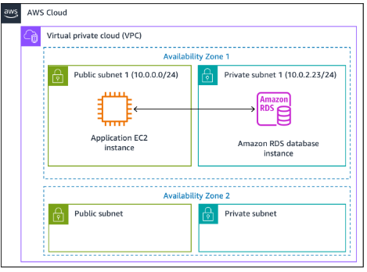
Duration
This lab will require approximately 20 minutes to complete.

AWS service restrictions
In this lab environment, access to AWS services and service actions might be restricted to the ones that are needed to complete the lab instructions. You might encounter errors if you attempt to access other services or perform actions beyond the ones that are described in this lab.

B. Accessing the AWS Management Console
To access the AWS Management Console, click on the button Start Lab and wait until the circle next to AWS turns from red to green
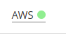

Figure 1: AWS Activated

C. Task 1: Creating an Amazon RDS database

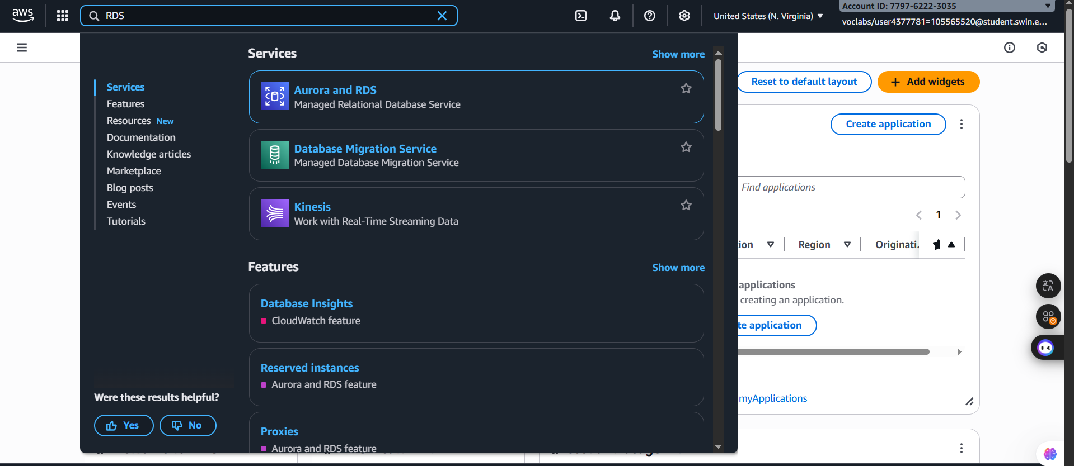
Step 1.1: At the top of the AWS Management Console, in the search box, enter and select RDS.
Figure 2: RDS Selection

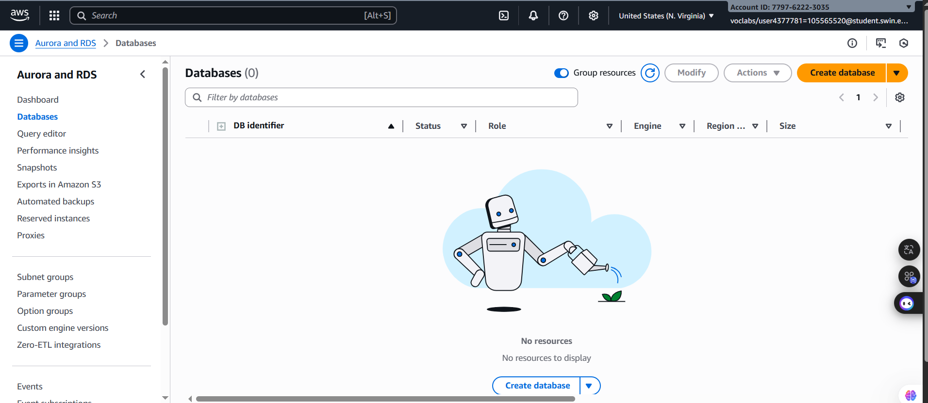
Step 1.2: Choose Create database.
Figure 3: Databases subpage

Step 1.3: Under Engine options, select MySQL.
The options include several use cases, ranging from enterprise-class databases to Dev/Test systems. In the options, you might notice Amazon Aurora. Aurora is a MySQL-compatible system that was re-architected for the cloud. If your company uses large-scale MySQL or PostgreSQL databases, Aurora can provide enhanced performance.
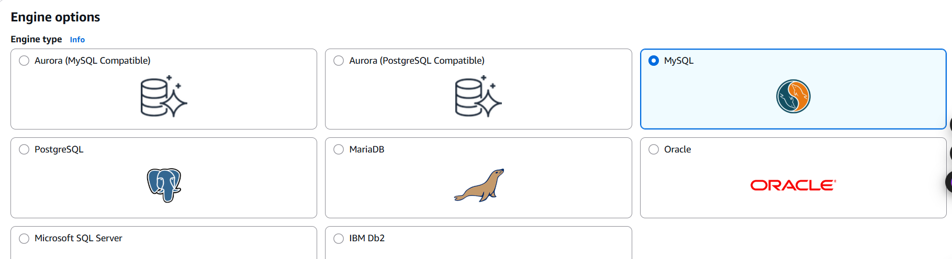
Figure 4: Engine selection

Step 1.4: Set the templates and availability and durability options:
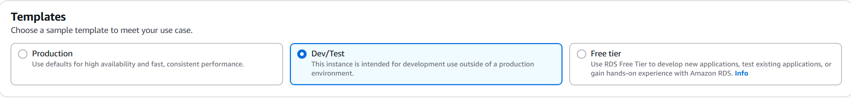
- Under the Templates section, select Dev/Test.
Figure 5: Templates selection

- Under the Availability and durability section, select Single DB instance
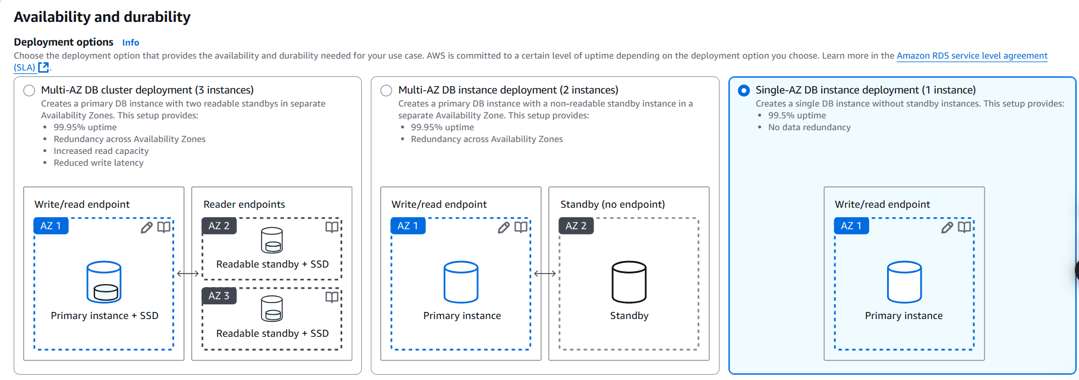
Note: the default Multi-AZ deployment option automatically creates a replica of the database in a second Availability Zone for High Availability, however in this lab that is not needed.
Figure 6: Availability and durability selection

Step 1.5: Under the Settings section, configure these options:
- DB instance identifier: inventory-db
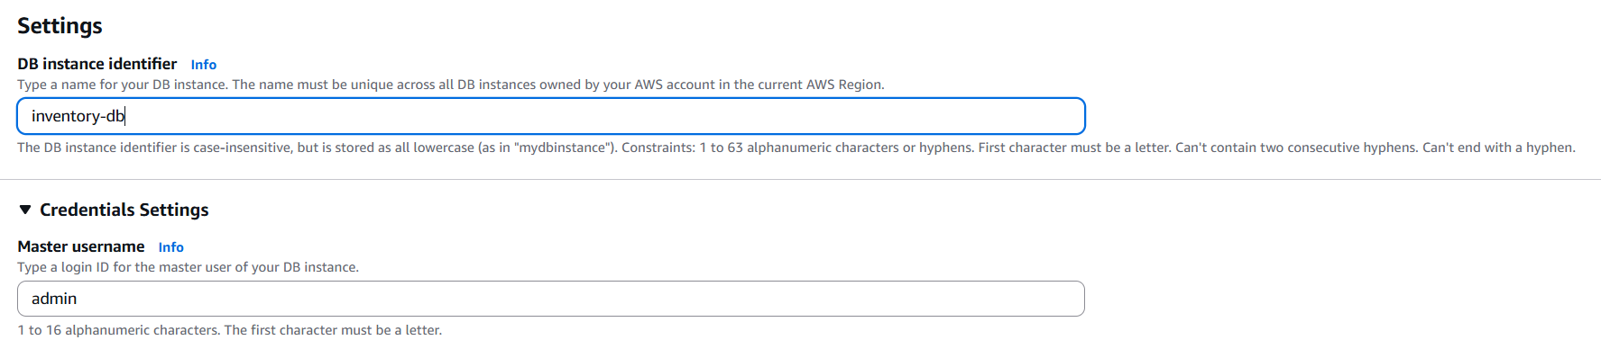
- Master username: admin
Figure 7: Database name and username configuration

Step 1.6: Under Credentials management, choose Self managed and configure as follows:
- Master password: lab-password
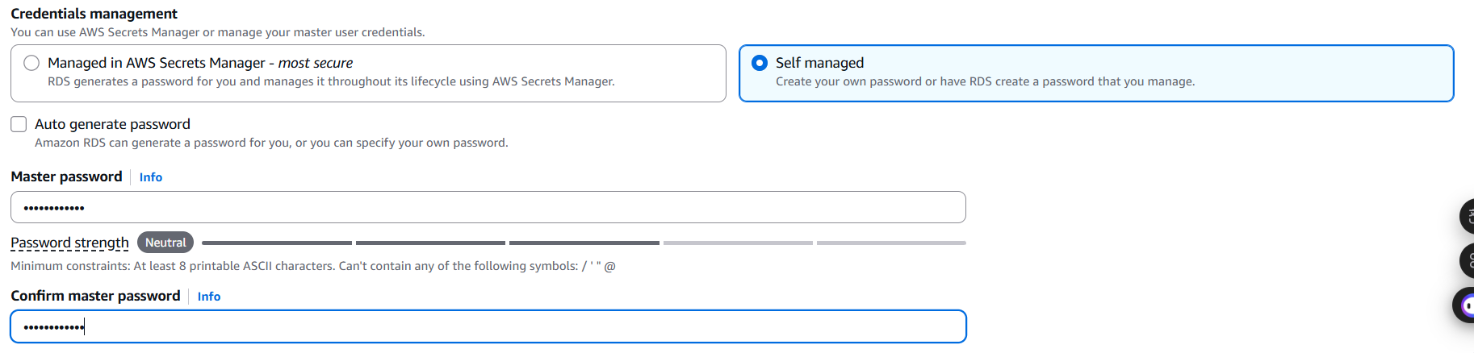
- Confirm master password: lab-password
Figure 8: Password configuration

Step 1.7: Under the Instance configuration section, configure these options:
- Select Burstable classes (includes t classes).
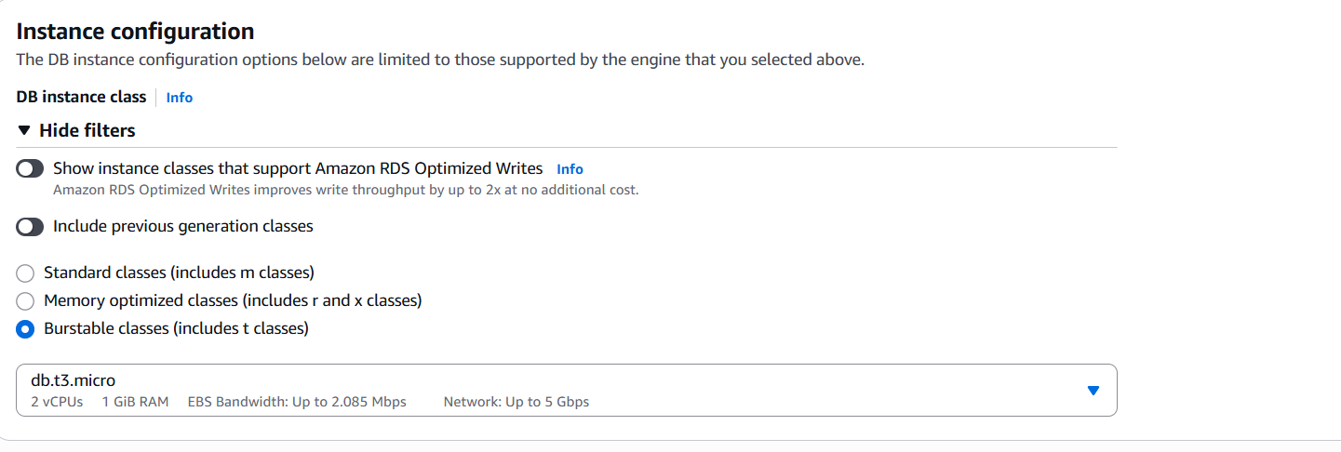
- Select db.t3.micro
Figure 9: Instance configuration

Step 1.8: In the Storage section next
- For Storage type choose General Purpose SSD (gp2) from the Dropdown menu.
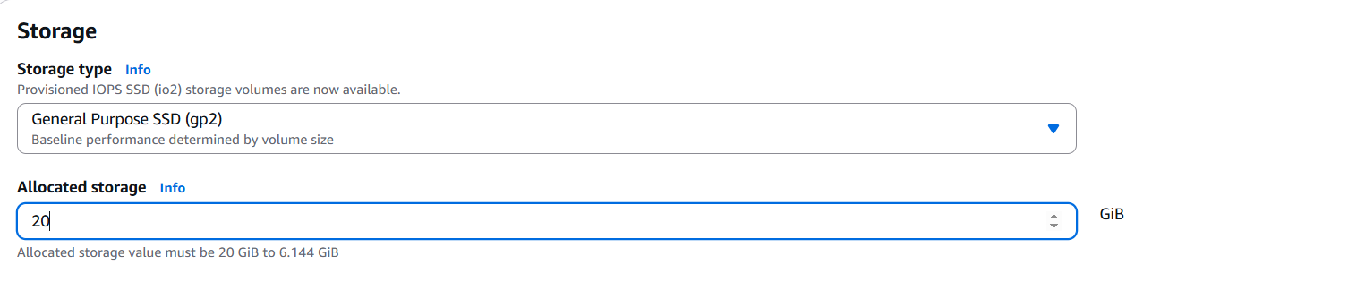
- For Allocated storage enter 20.
Figure 10: Storage configuration

Step 1.9: Expand Storage autoscaling
- Clear or Deselect Enable storage autoscaling.

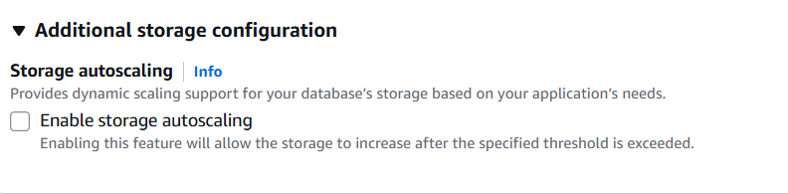
Figure 11: Additional storage configuration

Step 1.10: Under the Connectivity section, configure these options:
- Virtual Private Cloud (VPC): Lab VPC
- DB subnet group: Keep the default selection
Note: The subnet group created as part of lab setup has two private subnets, one per Availability Zone (AZ). This is required by the RDS service, in case the user changes the configuration to Multi-AZ in future.
- Existing VPC security groups:
- Choose DB-SG. It will be highlighted.
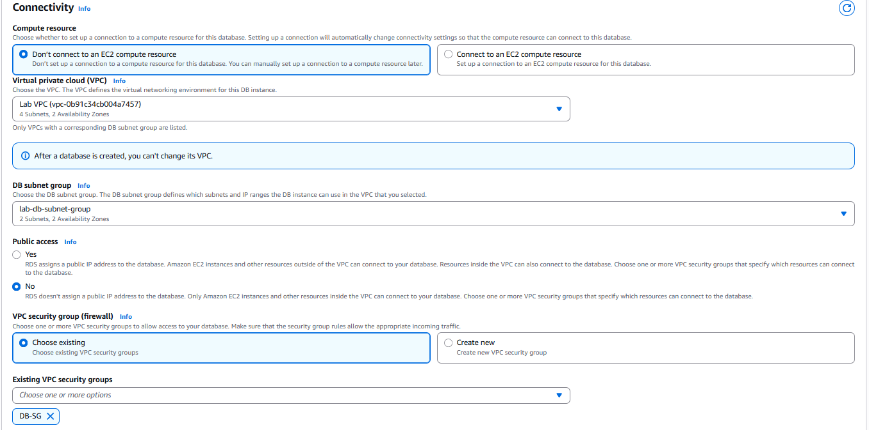
- Remove the default security group.
Figure 12: Connectivity configuration

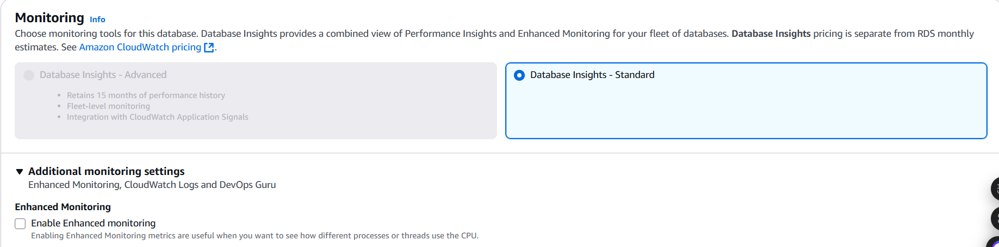
Step 1.11: Under Monitoring section, Clear (turn off) the Enable Enhanced monitoring option
Figure 13: Monitoring configuration

Step 1.12: Expand the Additional configuration panel, then configure these settings:
- Initial database name: inventory
Note: This is the logical name of the database that will be used by the application.
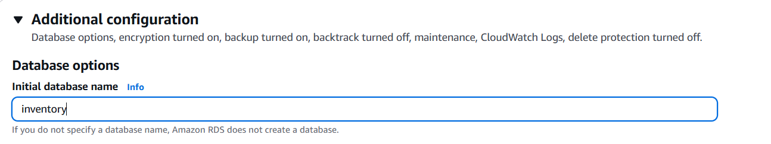
Feel free to review the many other options displayed on the page, but leave them set to their default values. Options include automatic backups, the ability to export log files, and automatic version upgrades. The ability to activate these features through check boxes demonstrates the power of using a fully managed database solution instead of installing, backing up, and maintaining the database yourself.
Figure 14: Additional configuration

Step 1.13: Choose Create database (at the bottom of the page).
You should receive a message indicating that your database is being created.
Before you continue to the next task, the database instance status must be Available. This process might take several minutes.
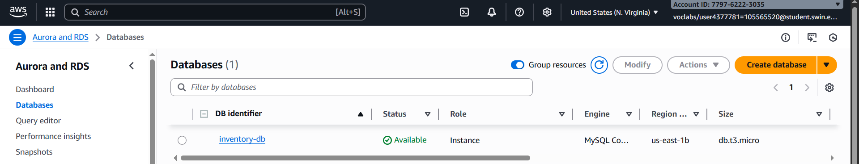
Note: If you receive a prompt Suggested add-ons for inventory-db, choose close.
Figure 15: Database created successfully

D. Task 2: Configuring web application communication with a database instance
This lab automatically deployed an Amazon Elastic Compute Cloud (Amazon EC2) instance with a running web application. You must use the IP address of the instance to connect to the application.

Step 2.1: At the Top of these instructions, from the i AWS Details section, copy the value for AppServerPublicIP.

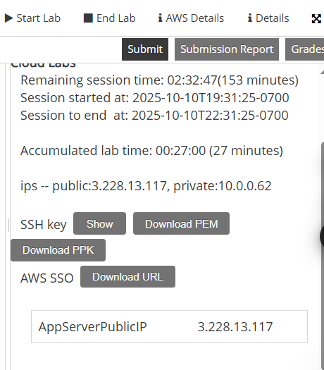

Figure 16: AWS Details

Step 2.2: Open a new web browser tab, paste the IP address you copied into the address bar, and then press ENTER.
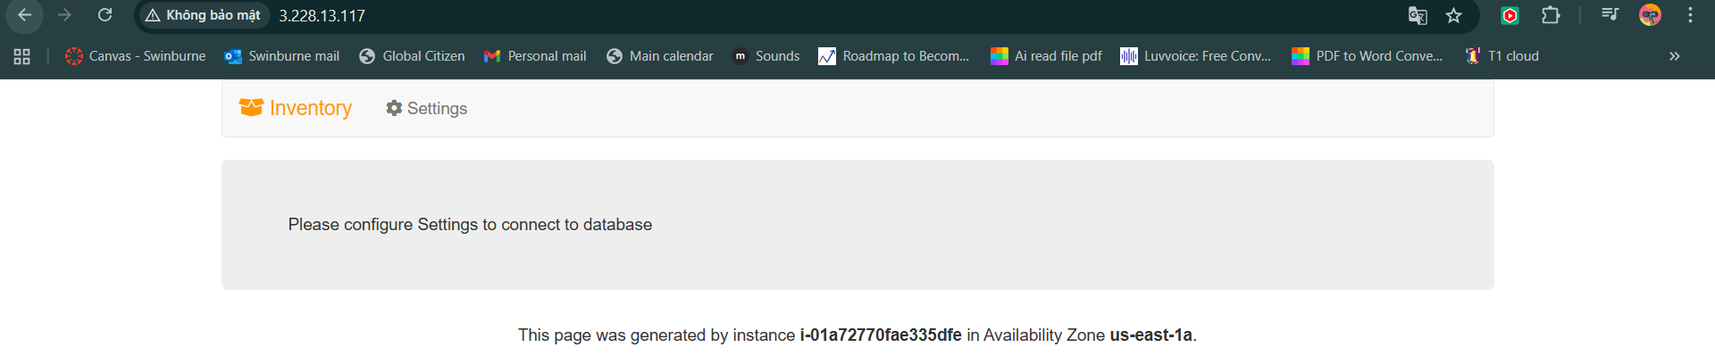
The web application should appear. It does not display much information because the application is not yet connected to the database.

Figure 17: IP Address page

Step 2.3: Choose Settings.
You can now configure the application to use the RDS DB instance you created earlier. You will first retrieve the Database Endpoint so that the application knows how to connect to a database.

Step 2.4: Return to the AWS Management Console, but do not close the application tab. (You will return to it soon).

Step 2.5: From the Services menu, choose RDS to open the RDS console.

Step 2.6: In the left navigation pane, choose Databases.

Step 2.7: Choose inventory-db.

Step 2.8: Go to the Connectivity & Security section and copy the Endpoint to your clipboard.
It should look similar to this example:
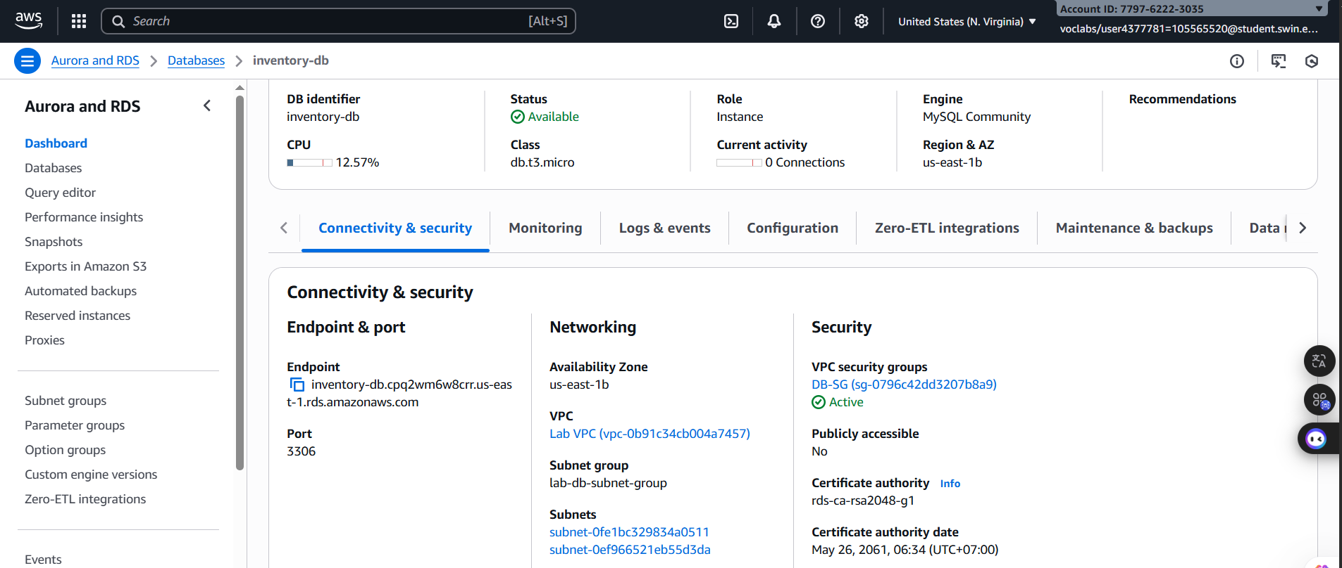
inventory-db.crwxbgqad61a.rds.amazonaws.com
Figure 18: Database Details

Step 2.9: Return to the browser tab with the Inventory application, and enter these values:
- Endpoint: Paste the endpoint you copied earlier

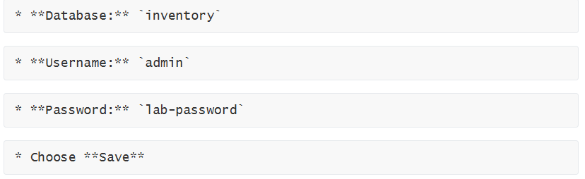

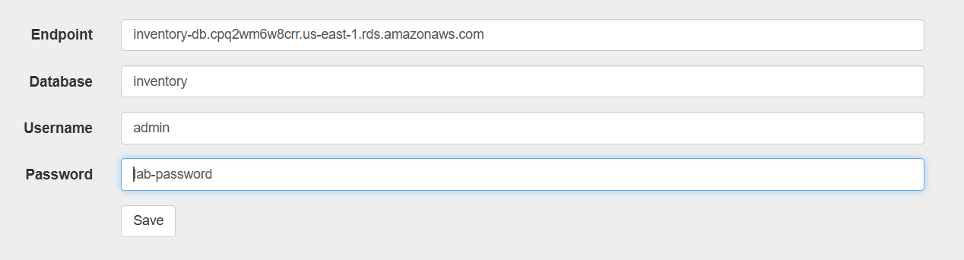
Figure 19: Setting Configuration
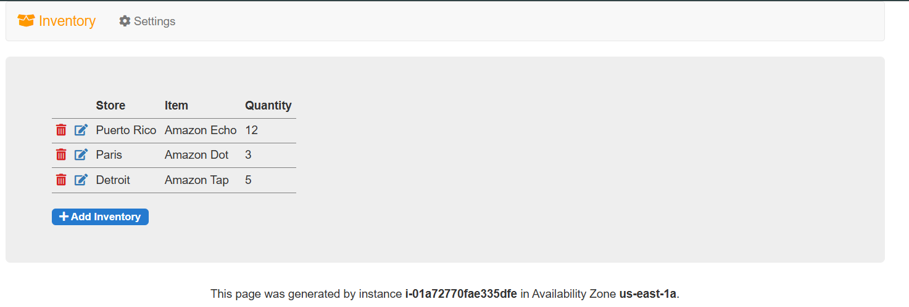
Figure 20: Load data successfully

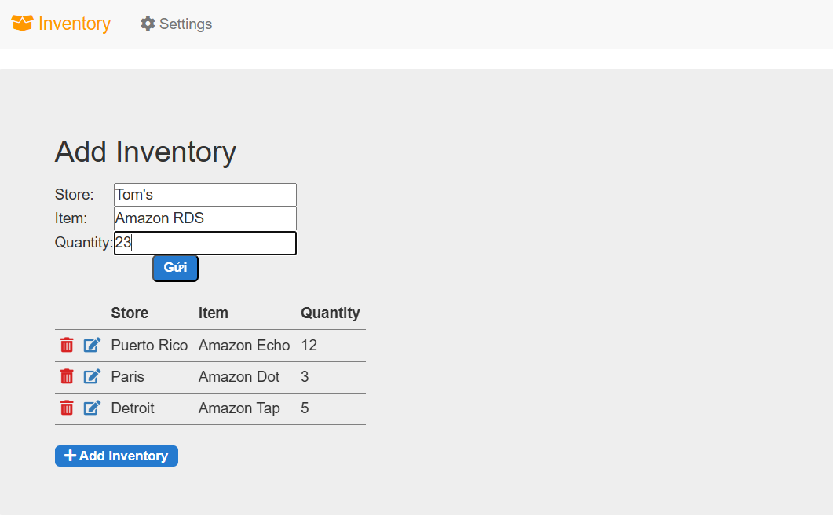
Figure 21: Add Inventory configuration
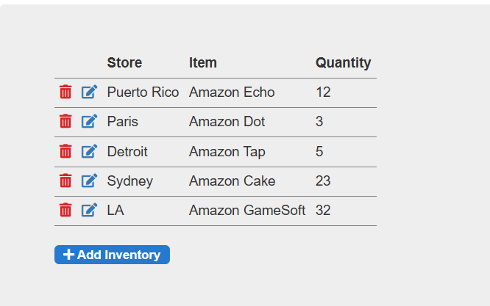

Figure 22: Insert Data

E. Task Completed

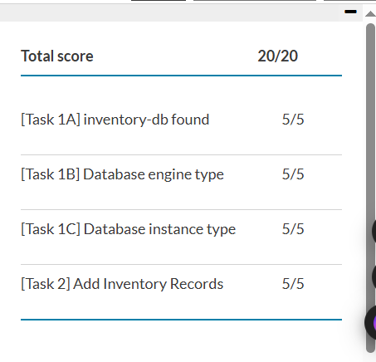

Figure 23: Task Completed

